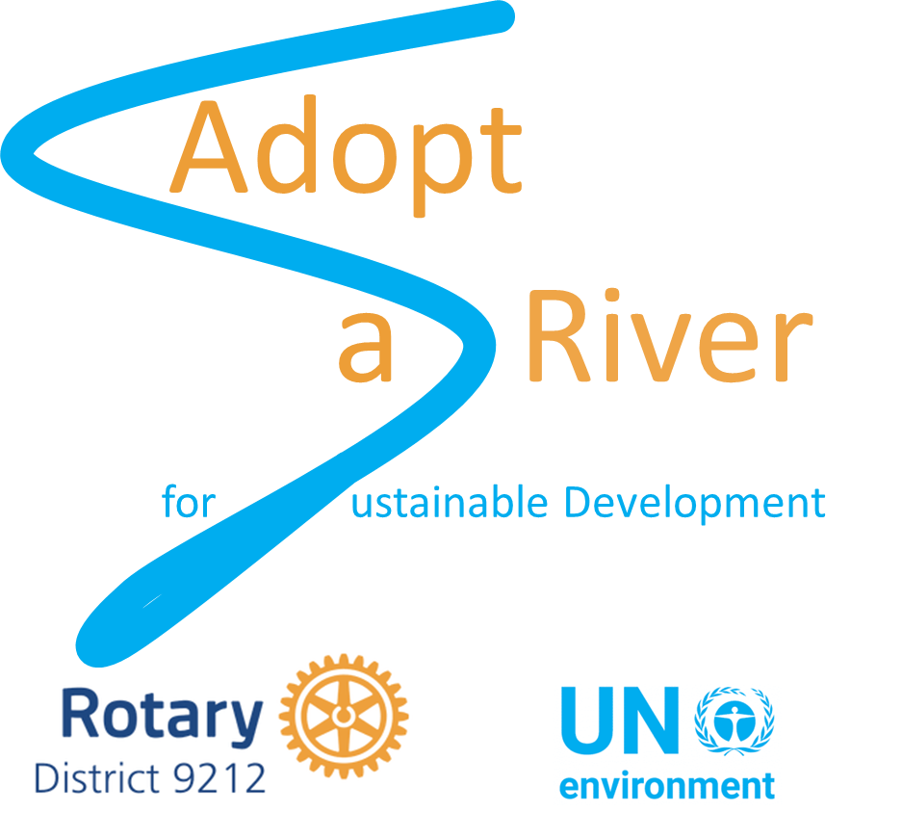

Adopt a River for Sustainable Development

Request for Proposals 1 – Clean Up +
December 2020

Introduction
Adopt a River for Sustainable Development (Adopt-a-River) has the goal of ameliorating the global water crisis through focused activities on freshwater ecosystems at a local level. The initiative provides a vehicle for engagement and action by community members, private enterprise and other stakeholders concerned about the degradation of freshwater environments and the impact this has on local people. Harnessing the power of communities, linked through a global initiative and backed by strong technical expertise, Adopt-a-River aims to protect, restore and sustain local freshwater ecosystems and ecosystem services to contribute to achieving the Sustainable Development Goals. Adopt-a-River centres around participating Rotary Clubs that identify a local freshwater ecosystem on which to focus their activities, develop a programme strategy on how they will protect, restore and sustain the waterbody and then carry out projects to enact the strategy.

For Rotary Clubs to design an effective programme strategy it is important to gain as much information as possible about the adopted waterbody. Key inputs into the strategy could be; an understanding of the communities’ concerns, priorities and levels of engagement, an identification of the major threats to the river, and a baseline assessment of the state of the river against which programme outcomes can be measured. An understanding of the feasibility of potential projects, and their likely effectiveness with reference to other stakeholders the plans and initiatives they have is also important.
Clean-Up+ is a methodology developed for Adopt-a-River to help Rotary Clubs gain information to develop an effective programme strategy whilst also proactively engaging the community in a hands-on intervention in restoring the waterbody. Clean-Up+ as the name suggests involves collection of solid waste from the waterbody and assessment of the type and source of the waste following an internationally recognised methodology. In addition, information is gathered about key aspects of the waterbody. This process allows as assessment of which stakeholders and potential partners are interested and engaged and to develop a deeper understanding of the threats facing the waterbody and the resources available to intervene.

Objectives
The key objectives of this funding allocation are to:
- Assist Rotary Clubs collect the information required to design effective Adopt-a-River programme strategy
- Assist Rotary Clubs in beginning their Adopt-a-River Programmes and begin the process of restoring the adopted waterways
- Provide data on solid waste and plastic in waterways for the Global Programme of Action for the Protection of the Marine Environment from Land-based Activities

Assessment Criteria
The funding is available only to Rotary Clubs within Rotary District 9212 for the purpose of conducting a Clean-Up+ project focused on the adopted waterbody. Priority will be given to Rotary Clubs that have identified an Adopt-a-River site and submitted the information to the Adopt-a-River Steering Committee (see the Adopt-a-River Processes and Procedures document). Priority will be given to clubs who have members that attended the Clean-Up+ CSIRO survey training held on the 6th of December 2019.

Application Information
Applications should be made by completing the application template provided in the annex and submitting this to the Adopt-a-River Steering Committee. A maximum of USD 3,000 will be allocated to each proposal and it is expected the project will be completed and reports submitted by the end of May 2021. Applications should detail the timeline for the implementation the planned activities how these will impact their Adopt-a-River programme and the waterbody in question.
It is important to include information on community and other stakeholder consultations taken in preparation of the application. Detail co-funding arrangements such as other financial support and expected in-kind contributions such as borrowed equipment, skilled or un-skilled labour and other technical support. The application must include information on the main outputs of the project, the indicators that will be measured to determine success and how this information will be monitored and reported. Completed applications and information should be submitted to Joe Otin on joe.otin@rotary9212.org.

Decision making process and time frames
Date | Action
16 November 2020 | Request for Proposal Opened
18 December 2020 | Applications submitted
15 January 2021 | Applications will be reviewed and selected by the Steering Committee
20 January 2021 | Applicants notified
01 March 2021 | Funds will be transferred, via district 9212
28 May 2021 | Projects to be completed
28 May 2021 | Data to be reported to Adopt A River Steering Committee
30 June 2021 | Final reporting (including full financial reporting)

Adopt-a-River Core Fund: Application Template
(Please be as concise as possible, the entire application should be no more than 4 pages, excluding attachments)
Name of Project :
Date :
Amount Requested (USD) :
Name of Waterbody and Site Name :
Rotary Club (District) :
Club President :
Adopt a River Lead Person(s) :
Contact details for project :
- Tell us a little about your project. What are the main objectives of the project, and who will benefit from it? (We are only asking for a general idea of the project. Try to be as consise as possible here. We’ll ask you for details later in the application.)

- How will you measure your project’s impact? (Use only measures that are clearly linked to your goals and will demonstrate the project’s impact on participants’ lives, knowledge, or health.)

Measure | Collection Method | Frequency | Beneficiaries

- Do you know who will collect information for monitoring and evaluation? (If yes, please provide the aneme and contact information for that person or organization and briefly explain why this person or organization is qualified for this task. If no, please tell us how you plan to find a person or organization to complete this task.)

- When and where wil your project take place?

- Provide the name, website and location of each cooperating organization. (A cooperating organization can be a nongovernmental organization, community group, or government entity. Please attach (Rotary’s) memorandum of understanding that’s signed by a representative of the organization.)

Name | Website | Location

- Why did you choose to partner with this organization and what will it’s role be?

Detail any laws, legal impediments or other regulatory issues that are relevant and how they will be overcome. E.g. access to private or public land, restrictions on planting types or numbers of tree or other flora, restrictions on modifying river flow.

- Describe the long-term plans in terms of project or impact sustainability and how it may be scaled up or out if successful.

i.e. How will the project or the impacts of the project continue beyond the funding period?

- Detail how communication, awareness raising and sharing of lessons from the projects will be carried out.

Expected Results Framework
(add additional outputs as required)

Output 1:
Activities (responsible parties): Who is doing what?
Output Targets : What will be achieved?
Indicator (success) : How will you know when you have achieved it?
Baseline : What is the starting point?
Timeframe : When will it be done?

Output 2:
Activities (responsible parties): Who is doing what?
Output Targets : What will be achieved?
Indicator (success) : How will you know when you have achieved it?
Baseline : What is the starting point?
Timeframe : When will it be done?

Project Workplan:
Main Activities | Responsible party | Months
 |  | 1 | 2 | 3 | 4 | 5 | 6 | 7 | 8 | 9 | 10 | 11 | 12

Summarize each step of your project’s implementation

# | Activity | Duration

Indicative Budget
 | General Category of Expenditures | Total (USD) | Description
1 | Supplies, commodities and equipment
1.1 | Equipment and rental of equipment
1.2 | Materials, goods
1.3 | Supplies
1.4 | Other
2 | Personnel
2.1 | Project staff salaries
2.2 | Local consultants
2.3 | International consultants
2.4 | Travel
2.5 | Other
3 | Training and Awareness
3.1 | Meetings, Trainings (including travel, rental of premises etc.)
3.2 | Other
4 | Contracts (including sub-contracts to third parties)
4.1 | Institutional Contracts (Sub-contracts)
4.2 | Other
5 | Other Direct costs
5.1 | Audio visual & print production costs
5.2 | Translation
5.3 | Postal
5.5 | Other
6 | Total Direct Costs
7 | Contingency Reserve (max 5% of Total Direct Costs)
8 | Total Direct Costs including Contingency Reserve
9 | Total Funds Requested

- Tell us about any additional funding you have secured for this project.
# | Source | Details | Amount | Total

- Will you purchase budget items from local vendors? Explain the process you used to select vendors.
- Did you use competitive didding to select vendors? If no, please explain.
- Have you found a local funding source to sustain project outcomes for the long term? If yes, please describe this funding source.
- Will any part fo the project generate income for ongoing project funding? If yes, please explain.

